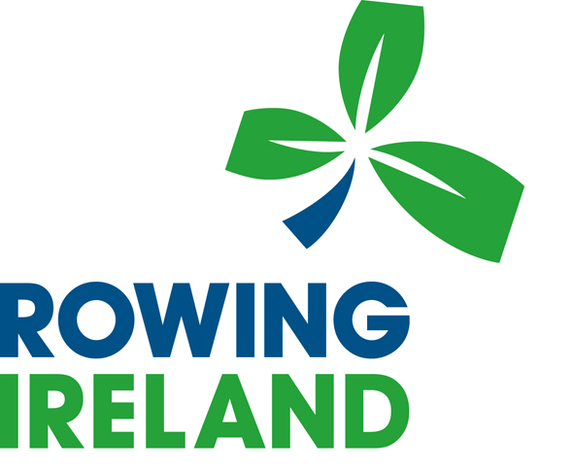
[ROWING IRELAND/NAME OF CLUB]
Induction Checklist for Volunteers

Name: Start Date: ______________

Role: _________________________________

The induction is to help new volunteers settle in as soon as possible; it should commence on the first day of joining and be completed as soon as is practicable.

Complete the form by entering the Rowing Ireland/Club Officer’s initials and the date alongside each item as the information or documents are given to the new volunteer.

If the induction is carried out by one Officer only and all on the same day, leave the sheet blank and complete the section at the end of the form.

Area | Item | Initial | Date
General Information | Explanation of Induction
General Information | Introduction to Officers & Committee
General Information | Introduction to any staff
Personal Details | Proof of ID checked (passport, driving license, birth certificate etc.)
Personal Details | Agree to attend Safeguarding awareness training
Personal Details | Safeguarding awareness training completed
Rules and Discipline | Codes of Conduct (to be signed)
Hours of commitment | Accurate hours agreed
Hours of commitment | Approximate if not known
Health & Safety | Rowing Ireland Safety Code
Health & Safety | Risk Assessments existing knowledge
Health & Safety | Risk Assessment Training required
Role and Organisation | Role description provided
Role and Organisation | Organisation Structure and services
Role and Organisation | Appraisal, Education
Role and Organisation | Training opportunities
Expenses | Allowances
Expenses | Training opportunities
Expenses | Insurance
Expenses | Other Benefits
Sickness / Illness | Protocol for informing Officer if unable to honor commitment
Holidays | Known holiday commitments
Holidays | Volunteers – as much notice as possible
General | Organisation contacts
General | Contacts with other clubs/RI
General | Policy when using facilities
General | Transport arrangements
General | Equipment availability
Trial Period / additional information | Default trial period of 3 months
Trial Period / additional information | Further reading/familiarisation identified for the probationary period e.g. specific policies and/or procedures.
Trial Period / additional information | RI Code of Good Governance
Trial Period / additional information | RI Policy Manual

Induction arranged by: __________________

I confirm that I have received the above induction training

Signed (volunteer): ________________ Date of Completion: ______________

PLEASE FORWARD THE ORIGINAL SIGNED COPY TO THE SECRETARY OF [ROWING IRELAND/CLUB].

